
FOUNDATION IN SCIENCE AND TECHNOLOGY

COURSEWORK COVER SHEET

SUBJECT TITLE : INTRODUCTION TO PROGRAMMING
SUBJECT CODE : FSTM3064
INTAKE : AUGUST 2023
COURSEWORK TITLE : REVIEW 2 – GROUP PROJECT
COURSEWORK : 20%

The objective of this assessment is:
- To apply adding graphical user interface design to Java application.
- To encourage students to think critically about the ways Java based mobile applications can enhance the lives of technology users.
- To expose students to various categories and types of mobile applications available in the market.
- To encourage students to design innovative mobile applications.
Instructions:
- Submit hardcopy and softcopy of your assignment.
- Please include a cover page, table of contents, and references in your assignment.
- Font type to be used Times New Roman, 12 with 1.5 paragraph spacing.

Student Name: Hoh Xin Hui, Lim Feng Wei, Sian Yi Xuan, Teoh En Yi
Student ID: 23080609, 23062334, 23099609, 23051105

Problem Statement
Users had a range of issues when they are utilizing shopping applications even during the Covid-19 epidemic, where people were in the lockdown phase and had to stay home for the time being. The usage of shopping application raised drastically during the pandemic as people didn’t have to go out to purchase items and it was rather convenient for customers. Nevertheless, there were difficulties faced by users such as the complicated navigation of the applications. Some shopping applications were cluttered with information and had confusing navigation menus which made it even hard for users to locate certain goods or categories. Complicated navigation heavily affected the customer’s ability to finish transactions efficiently.
Furthermore, the inconsistent layouts across different parts of the program or across desktops and mobile versions causes user confusion. The lack of consistency in the design aspects such as the button placements, colour schemes and typographies interrupt the purchasing experience of users and made it difficult for the application to run smoothly. Other than that, a poor search engine causes the application to look run down. When customers purchase online, they would make mistakes frequently and would often overlook their errors, thus assume that their product was unavailable when they see the zero-result page. Customers occasionally find it frustrating when they need to locate their desired product as it takes up a lot of time when there are irrelevant results being displayed.
Moreover, when users are completing payments, they frequently run into problems of locating alternatives to make payment. Some users may not know how to proceed with transactions using credit or debit cards, and this may lead to users experiencing anxiety when they are making online purchases since they would have to possibly use personal information. Some customers may have the fear of leaking any personal information as they use online transactions which has the possibility of that happening.

Review on Existing Shopping Applications
- Shopee
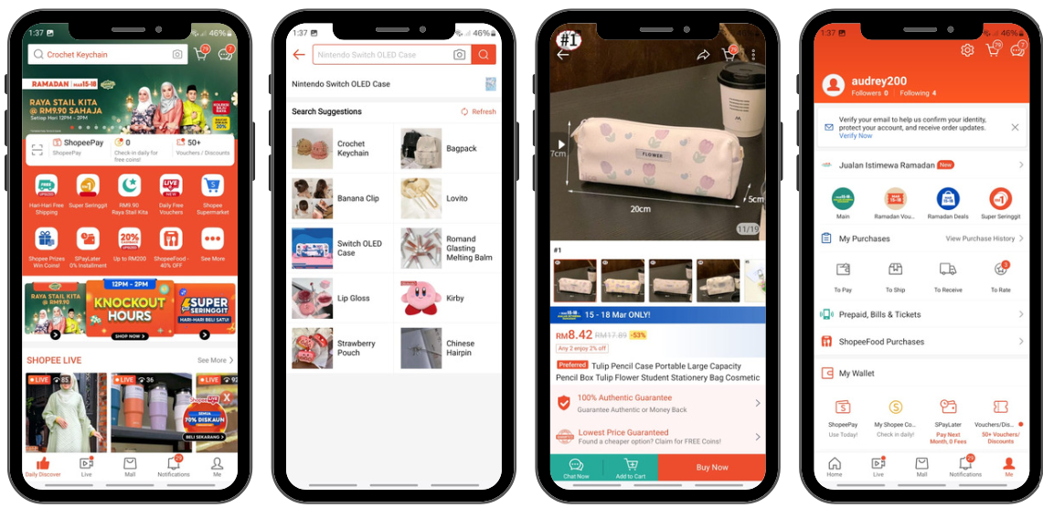

Description
A Singaporean firm called Shopee has one of the current greatest online shopping applications. They provide a wide variety of categories, which include games, collectibles, computers, food, fashion and beauty, which users can buy or sell groceries and clothes with just one swipe thanks to the user-friendly app. They ensure that the payments that are made is secure by both buyers and sellers. The millions of users that the Shopee app has in the Southeast Asia is tailored to the demanding marketing needs of the area.

Benefits
Shopee has a strong rating and feedback system that ensures users to interact with reliable merchants. Users may create and browse through many listings with the application, and they can have a real-time interaction with potential customers without having the need to download or pay a commission. In addition, the app provides a “Shopee Guarantee” feature that guarantees that the products will be delivered in flawless condition or that the buyer’s money will be fully refunded in case of any refunds made by buyers. Users can shop by the region. Once the user is on the app’s home screen, the user can select their nation of residency to be sent to the shop that accepts their currency and nation of residence.
The GUI (Graphics User Interface) for the application adopts a minimalistic, simple and user-friendly layout. To start off, Shopee offers flawless UI (User Interface) and UX (User Experience) design. The app provides effective use of white space that leads to an information structure that is simple, straightforward and free of cluttering. This design decision results in an interface that enhances the user’s comprehension of the various options while also being aesthetically pleasing to the eye. Shopee has demonstrated its dedication in providing a user-friendly searching experience by including features such as a search history, history list, recommendation list and search by picture. Examining the user page of the application, it reveals an interface design that combines utility with user focus. A smooth and intuitive experience is supported by the distinct and tidy division of functions.
On the other hand, the information hierarchy prioritizes the needs of the users and places the crucial information on the top which can help guide users towards the desired actions. The “Buy Again” section enhances the efficiency of the website by streamlining the user’s purchasing experience by providing easy access to past purchases, with its functionalities arranged to align with the user’s journey. Customer’s satisfaction is then further enhanced, and the interactions are streamlined with the user-centric approach.
It is evident from a cursory look at Shopee’s menu bar that the company excels in user experience. It does not only provide access to more useful features such as the “ShopeeLive” and “ShopeeMall”, but it also includes a well-known UX pattern with the cart symbol on the top of the page which complies to the customer’s expectations. The app links the bonus point to the element of grouping that is less complicated and it is similar to the best practices in UI design. The homepage, alerts as well as the profile page for instance are all located on the app’s menu bar, and these are crucial features for a user’s purchasing experience.

Limitations
Although Shopee is widely used by many in the Southeast Asia, there is always space for improvements to be made. To begin, the individual product page of Shopee can be considered cluttered as there are some unnecessary information portrayed on the page. For example, the voucher redemption is present on the page which distracts users from the crucial information of a particular product. Other than that, the shipping fee section is also present in the individual product page which is considered unnecessary as it can be placed at the checkout page. The application features a poorly defined information structure and several unused areas. Knowing which information is crucial might be a pain for users when it is organized such that it seems practically identical. Furthermore, even with the app’s brand colour, users are not immediately drawn in when the price and discount sizes are tiny.

- Lazada
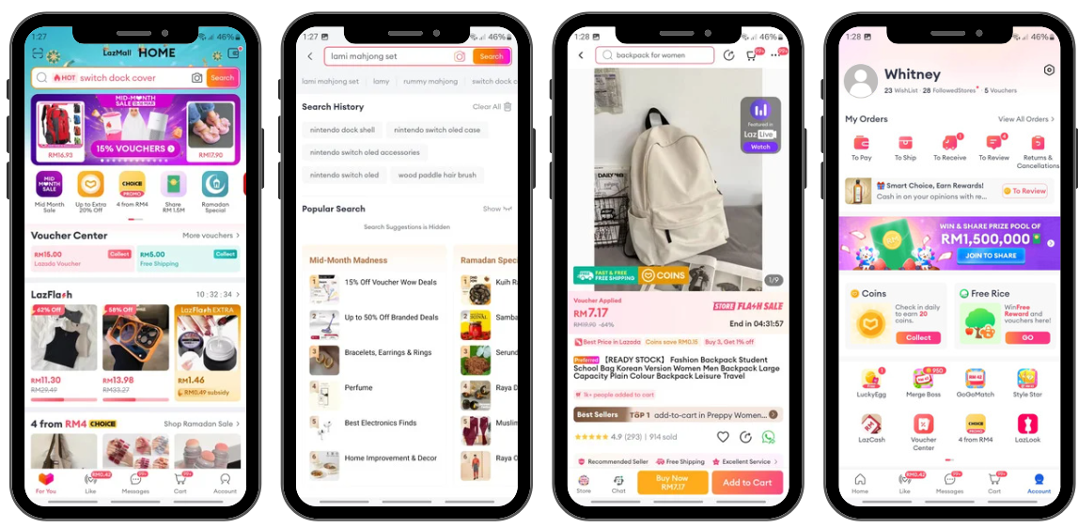
Description
Having operations in six countries – Indonesia, Malaysia, the Philippines, Singapore, Thailand, and Vietnam – Lazada is a prominent e-commerce platform in the Southeast Asia. Fast, safe, and easy online shopping is offered by Lazada app, which also offers a large selection of products in categories including fashion, consumer electronics, toys, and home items. The app constantly provides their customers with the best deals possible, which includes a wide range of payment alternatives, free returns, and promises of comprehensive customer care and warranties.

Benefits
Lazada’s homepage takes up a more sophisticated and straightforward approach. It is evident that when full screen advertisements are displayed, proper use of white space improves advertisement contrast. The UI (User interface) and UX (User Experience) design for the product pages are well-developed and this accomplishes a lot of great user experience goals. The page is clear and the fact that product pricing and discounts are bolded and emphasized makes them obvious from the outset. Users can concentrate on the crucial information thanks to its visual hierarchy, a clear and orientated information. The shopping cart page has excellent UX compared to other application. The “Collect Voucher” option is more prominently displayed at the top of the page which encourages users explore more and keeps them longer occupied using the application.
Another helpful addition that facilitates the restocking process and encourages user engagement and app loyalty is the “Buy Again” feature. Furthermore, the pre-checked boxes in the basket help to expedite the checkout procedure even further. By having users manually choose the products for purchasing, this design eliminates an additional step and mental strain for users. The application has a neat and systematic method for handling its product listing page. In addition to having a more streamlined user interface for its product search filter, the product listing page features a superior visual hierarchy, contrast, iconography as well as grouping all of which improves the navigation and encourages user interaction.

Limitations
Improvements on the application can always be made to maintain the user-friendly concept of the application. Compare to other applications that are more advanced, there are several shortcomings with the Lazada’s wallet. The wallet symbol on the webpage is not very visible, thus resulting users are unable to get their wallet in an emergency due to the less visible location. This increases the level of user experience complexity. On the first half of the page, the blue colour choice fits in perfectly, but with time, it creates visual clutter. Users fins it confusing to navigate downward due to the colour combination and plenty of commercial banners. The transaction history just makes matters more complicated. It is rather a hassle that users must scroll past the promotional area to find its availability.

- SHEIN
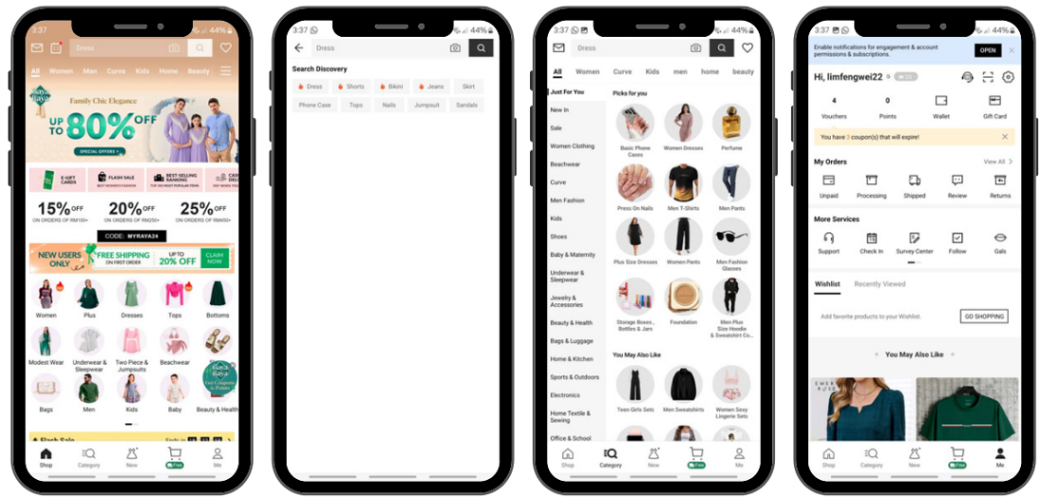
Description
Global exports of ultra-fast fashion are the primary goal of the Chinese internet enterprise SHEIN. Offering a vast and constantly evolving assortment of extremely affordable fashion goods with an emphasis on exports – it presently ships to more than 150 countries – is the company’s business approach. Appotia(2022) stated that the firm has 193 million downloads, making it the second most downloaded shopping app globally.

Benefits
Hasty navigation is more detrimental compared to hurried reading. Users typically follow this pattern and choose the navigation option with the highest information fragrance rather than looking through all the possibilities. Using the application demonstrates the core of information-foraging theory, which is the basis for the navigation of digital information. SHEIN allows users to browse by category, much very like other significant online shopping applications.
While subcategories (Recommend, New in, Shoes, etc) are shown in the left corner, the main categories (Women, Men, Kids, etc) are listed on the top. A setup like this not only allows for powerful filter and category selection, but it also lessens the accidental clicks and user confusion. Heuristics No.2 and No.9 are effectively combined in SHEIN’s e-commerce design process. The app employs a tool that many e-commerce businesses utilize, which is a fit finder aspect. It assists users in choosing shoe sizes. This feature lowers the possibility of further return expenses for the business as well as it guarantees the users a flawless purchasing experience.

Limitations
The application does have a few weaknesses such as the excessive information provided to the users. This causes user confusion as well as cluttered webpage. Users would find it difficult to search or identify crucial information with such messy webpage. Other than that, the application lacks blank spaces which proves that the layout of the webpage is overly crowded. The product search and review section does have a few disadvantages. The filter contains too many options which leads to unorganized layout, and it results in the unappealing design. The search engine could also be replaced with a search icon which eases the user’s experience.

Proposed Application
The proposed application is “OffBuy” which aims to provide users with the utmost ease and a smooth experience when browsing and purchasing goods online. What sets the application apart from the competition is that it has less complexity with is user-friendly and it is easy for first timers to understand. The application would also take the best existing applications and improve the existing functionalities. With that being said, “OffBuy” provides user an advanced in-app search engine. Practically no respectable e-commerce would operate without a search engine. The search engine would be visible and easily accessed by users and it contains advanced filtering and sorting feature which eases the user’s experience. The in-app search engine can effectively interpret the user’s intent and fixes problems.
In addition, the application will have an augmented reality by using materials found in photos or videos, this technology can create interactive replicas of the actual environment. For instance, it can display to users whether furnishings would fit flawlessly in their living room or whether a makeup palette would complement a certain skin tone. It will take the user experience to a new level once this cutting-edge technology is involved in the application. Furthermore, the individual product page of our application will have less cluttered information and will only focus on the crucial information of the product itself. This reduces user confusion and smoothens the purchasing process of the user.
To add on, the payment methods are to be secured so that there will not be any leakage of personal information about the users and there are alternative payment methods which include credit and debit card, e-wallet, online transfers as well as physical payments. This streamlines the purchasing process of users thus leading to a better user experience. The reviews in the comment section will be authentic through our validation process. This ensures the credibility and confidence in the reviews, thus allowing the users to purchase depending on the feedback and the experience of other users without a heavy heart. Moreover, “OffBuy” will be prioritising the transparency of prices, discounts as well as the hidden charges of each product, thus ensuring the seamless and trustworthy purchase journey of each user.

Logical flow
- Registration: Customers access the OffBuy app by creating a new account with their personal details provided such name, email, and password.

- Home Page: Users will enter home page, where they can select for different categories of product that we keen to buy. Users able to look at the ratings clearly and have a great scroll down tour of listings. Discover, notifications, cart and profile are included in the homepage.

- Notifications: Users able to receive notifications including order confirmation, shipping information, delivery alerts, and promotions. Throughout their purchasing experience, users can stay informed and involved with the support of these notifications.

- Profile: Users can access and edit their personal details. Users can also view their wish list, recently viewed and purchase history. This step allows users to maintain control over their account settings and preferences.

- Search: Users browse through their desired products, and they can apply filters to sort for the products that fulfilled their need.

- Product Suggestion: Product suggestion will be showed to the user based on the browsing history, recent popular products, and previous purchases to improve overall shopping experience.

- Product Selection: With the filtered product list and suggestions, users can then browse through the displayed items and select the most interested one for further consideration. They may click on product thumbnails to view product descriptions, images, and reviews before adding into cart.

- Shopping Cart: Users review the items in their shopping cart, modify quantities, or remove items as needed before proceeding to the checkout process. Users able to manage their selections and make final decisions before completing their purchase.

- Checkout Process: Users proceed to the checkout process where they provide necessary information such as shipping address, select shipping methods, and choose payment options to complete their purchase.

- Payment Processing: Users securely choose the payment method and enter payment details before proceeding to order confirmation.

- Order Confirmation: After successful payment processing, users receive an order confirmation via email and application’s notifications with details that contains order number, items purchased, total cost, and estimated delivery time.

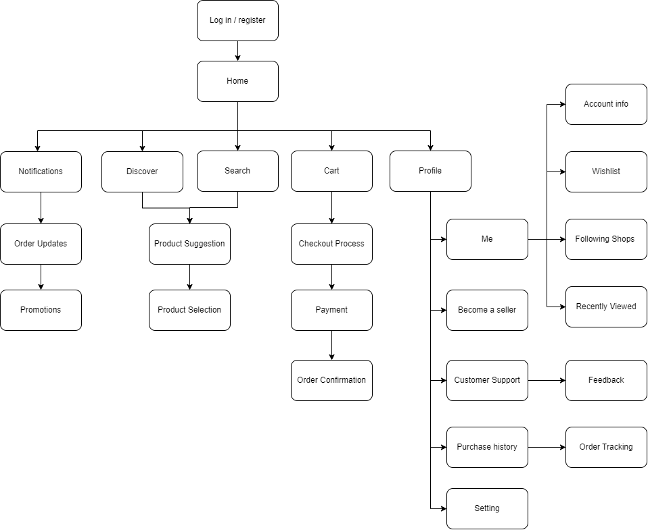

Mock ups of the application

Login Page
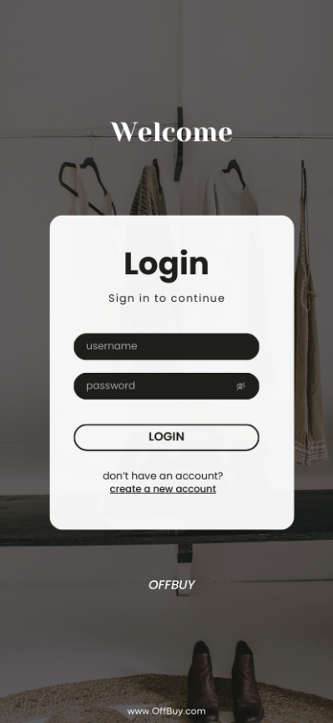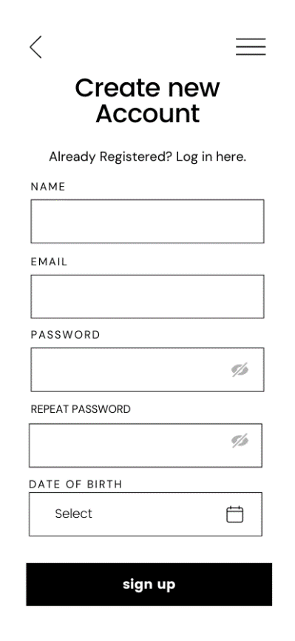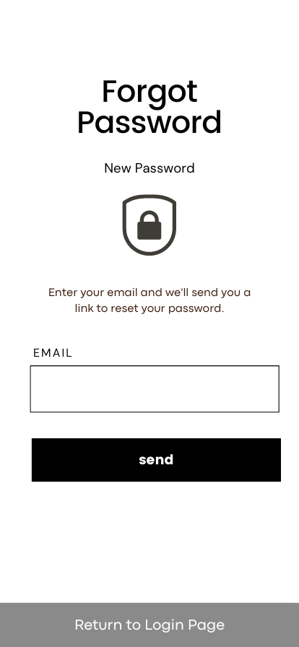

The UI (User Interface) of the login page is clear and it is user friendly. The login page allows users to clearly input their details. New users can create a new account with ease and without any trouble. Other than that, in case when users who tend to forget their logging in details such as their password can click on the forget password button which allows them to recreate a new password. After that, users able to return to the login page to proceed the login process with new password.

Home Page
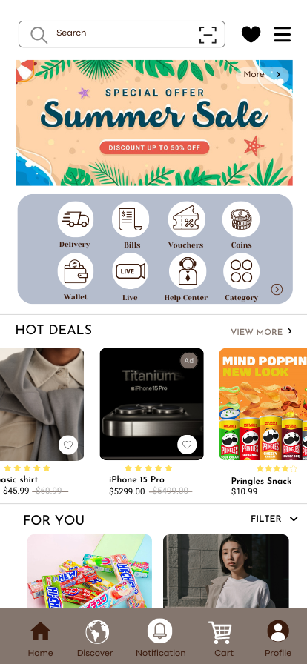

The home page has a consistent layout, and this reduces user confusion. The icons are simple yet understandable by users, even new users. The page is user friendly as it provides a visible and advanced search engine. With this, users are allowed to search for their ideal product with the assistance of product suggestions that will appear after users enter the keywords. Other than that, it has a category button which allows users to access different categories at ease.

Individual Product Page
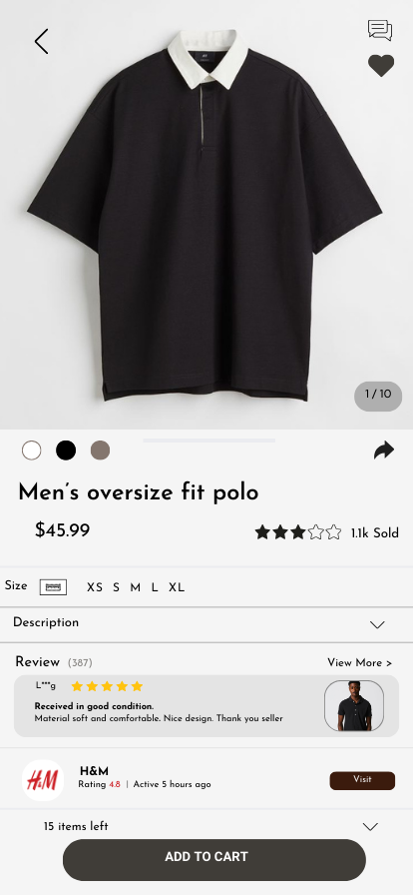

The individual page product is minimized yet informative. It does not have any cluttered and unnecessary information which annoys or confuses users when viewing a particular product and this eases the user experience. The review of products is authentic as well as informative which helps user to determine whether they would like to purchase the product base on the reviews from previous buyers. The shop is shown below as users can visit the shop profile for more products from that shop. If users interest the product without immediate desire to purchase yet, users can save the product into wish list for future reference. Aside from that, users can click on the add to cart button to add the product in their cart for checkout. The remaining number of the product is shown as users can know whether the product is still in stock. The description of the product is presented to the user as this helps the user to understand more about the product. The choices size or colour of a product is shown clearly.

Shopping Cart page
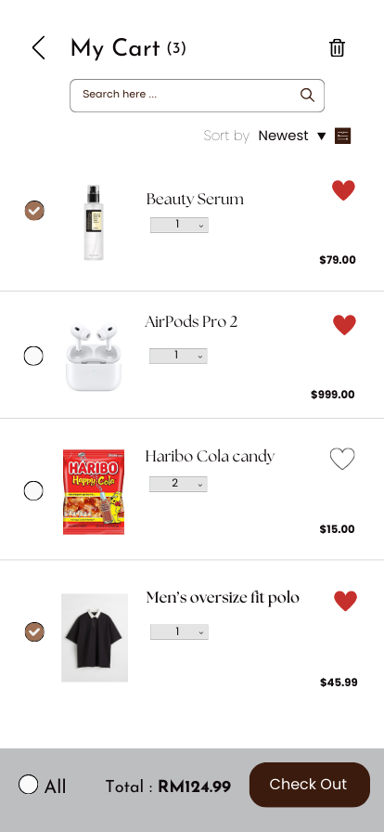

The cart page is properly organized so that it is not cluttered. The search engine is present for users to look for items that they have previously put in their cart. The sort and filter are present to help users to view products at ease. Besides, users can choose the product that they wish to purchase by clicking the button beside the product. Users are also able to delete any unwanted items as the icon is right on the top. The total amount is shown clearly for users as well as the check-out button.

Checkout Page
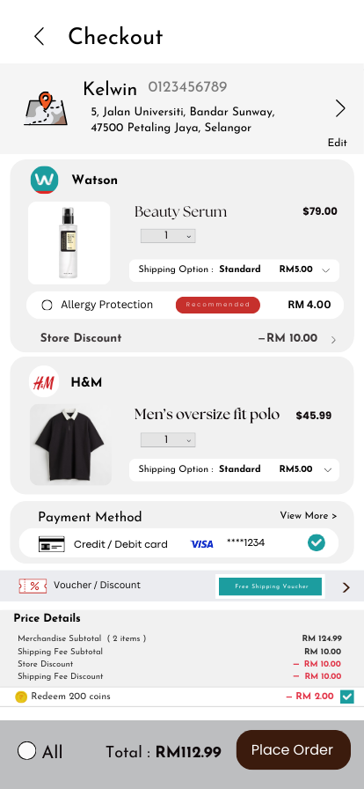

The user’s address bar is right on top so that users can make sure that the address is correct and to avoid mistakes made. Beside the address is an edit button which allows users to make changes to their address. The selected product from the cart is displayed here. The shipping fee, discounts and the total are displayed clearly to avoid any hidden fees. The payment method can be selected as there are a few alternatives to choose from. Vouchers or discounts can be used and selected from. These have created a user-friendly and stress-free experience for users that able to reduce barriers when they are going to complete purchase. Therefore, shopping cart abandonment rate can be reduced efficiently.

Profile Page
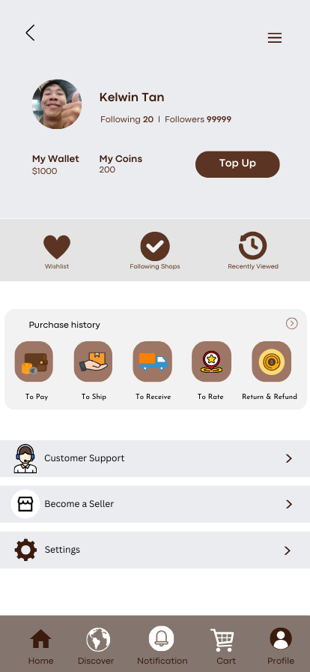

The profile page features in clean and easy-to-understand layout which is essential to enhance users’ experience and ensuring convenience. Key elements such as users’ detail, purchase history, and activity history are displayed. These have allowed users to quickly locate and manage their account settings easily. The layout is designed with simplicity in mind, employing clear labelling and logical organization to enhance user comprehension. Additionally, users are allowed to give feedback in customer support to express their overall experience in OffBuy. Users can modify the settings according to their preferences such as language and privacy settings to provide them with a personalized space.

Stakeholders
The COVID-19 outbreak, which started in Wuhan, China, has affected the Malaysian e-commerce ecosystem since 2020 until now. The enforcement of the Movement Control Order, also known as MCO, started from March 18, 2020, until August 31, 2020, went through different phases, and restrictions nationwide accelerated at the same time, expanding the local e-commerce market in different sectors. Due to the enforcement of MCO, the number of new users of e-commerce and online shopping applications has boosted. The COVID-19 pandemic in 2020 proved to be an incredible blessing for Malaysia's e-commerce industry, helping boost growth by up to 37%. (View of IMPACT OF COVID-19 ON MALAYSIAN E-COMMERCE | International Journal on Recent Trends in Business and Tourism (IJRTBT), n.d.)
It is undoubtedly true that online shopping applications have made people more convenient, as they no longer need to go out to buy their essentials, groceries, etc. In Malaysia, people were attracted by the amazing features of online shopping applications as they were not allowed to go out of their residency due to the lockdown policies. The emergence of online shopping applications not only blocks the infection chain of COVID-19 but also helps fellow Malaysians purchase items at a cheap and reasonable price. According to semrush.com, with 108,321,792 visits, Shopee (shopee.com.my) became the most visited retail website in Malaysia in February 2024, followed by Lazada (lazada.com.my) with 24,625,178 visits. (Top Retail Websites in Malaysia - Top Rankings February 2024, 2024). In addition to increasing their revenue and expanding their business by selling their products to other states and regions, traditional physical store owners also often manage their online stores simultaneously.
There are two types of stakeholders: internal stakeholders such as employees and owners and external stakeholders like customers and competitors.

Stakeholders
Internal stakeholders: | External stakeholders:
- Employees  A company will not run smoothly if it cannot treat its employees well. This is because the presence of fellow employees ensures that every department of a company runs flawlessly. Imagine if a prestigious and large firm is short of manpower. What will happen? There will be an increased workload for existing employees, which leads to a high level of stress and frustration, and then they will jump ship to another company, which is better. | - Competitors  Offbuys will face competition from newer apps like Shein, which offer better and more packed with features to customers. Therefore, to meet the needs of the present user base, developers must be updated. In addition, it's important to look at customer feedback to identify errors in the program.

Market Reach & Targeted audience
The objective of Offbuy is to fulfil people's buying needs. No matter where you are from or what kind of items you need, Offbuy will send the products to your doorstep as soon as possible.

- Ordinary people just like us
Offbuy targeted ordinary people just like us, who are finding places to buy our essentials, groceries, skincare, etc. It is crucial for us to compare the prices between different stores, as sometimes the selling price can be quite different from store to store depending on their location. Shops and stores located in prime locations tend to mark up their selling price to cover their rental, electricity, and water bills. With Offbuy, people no longer need to go out to buy their things; what they need to do is just open the app and type in the item’s name in the search bar in just a few clicks. Then, OffBuy’s logistic partners will send out the parcels from logistic hubs located in a variety of regions. The app not only lets consumers compare prices between sellers but also lets them see the estimated delivery date for their parcel. The UI (user interface) and UX (user experience) of the app are comprehensive, which gives consumers a better experience.

2. The owner of physical store
The owner of physical store can use OffBuy to supply their stock. The app offers the buy-in-bulk option, which lets these owners buy their stock at a cheaper price compared to traditional suppliers. Then, the owners can resell at a higher price and pocket the differences. The buy-in bulks option offers a wholesale price that is lower than the normal selling price. Furthermore, Offbuy provides a chat function. This function is a chatroom for both seller and buyer. The buyer can ask whatever they want to ask. In this chatroom, both sellers and buyers can attach photos and videos.

3. Workaholics
Workaholics can benefit from OffBuy. They don't have time to go shopping, so they may make quick purchases with the app, which will have the package delivered right to their home. OffBuy’s logistic partner can dispatch their package the same day before 12 a.m. if the item they purchased is from the same state as their address.

- For those looking for products that they are unable to find in a physical store.
OffBuy is especially helpful for those looking for products that they are unable to find in a physical store. Due to the diverse nations of the app’s sellers—including Mainland China, Indonesia, and Vietnam—the users can locate their products, which might not be available locally, thereby expanding the app market internationally.

Monetizing strategy
OffBuy’s goal is to give users access to a well-developed and comprehensive online marketplace, as well as funding for app enhancements. Setting up a list of effective tactics is thus essential to consistently monetize OffBuy.

- Introduce the premium listing option, which allows sellers to advertise their products.
Advertisements in OffBuy can be placed by any seller for an additional charge. The chosen products will appear at the top of the listing if a seller pays to display their ads. The advertised items will appear above the other non-advertise items when users search for relevant keywords. To differentiate boosted items from non-advertise items and prevent user confusion, all boosted items (also known as advertise items) will have a badge labelled "Ad" to indicate that they are advertisements. The best-selling items or new items that need to be tested for potential could be selected by the seller to be boosted. Additionally, sellers can decide the duration of their advertising and budget; the premium listing will run until they run out of credit. The seller can then choose to top up their ad credit if they would like to keep running the adverts.

2. Transaction fees and commission fees.
After an order is successfully completed, all sellers get charged a small transaction fee by OffBuy to cover the cost of the payment gateway while profiting from it. The app accepts payment methods that include credit and debit cards, e-wallets, online transfers, and physical payments. So, it’s reasonable to charge a small transaction fee to cover the cost of the payment gateway. The transaction charge is computed as 2% of the total order amount that the buyer pays (shipping included). When an order is completed, OffBuy will automatically deduct the transaction charge from the seller's compensation. On the other hand, sellers will be charged 3% commission fees if they have been selling on Offbuy for more than five months, starting from the seller's first product listing. The collected commission fees will be used for software updates, improvements, hiring more experts, etc.

3. Selling e-vouchers
The app allows sellers to buy vouchers in bulk to use for promotional events. For example, sellers can give out vouchers at random to their loyal customers as a sort of reward when they make sales on the platform. Another option available to the sellers is to build up a mini program that resembles a spinning wheel game. Different portions of the wheel are labelled with different amounts of vouchers; when the wheel spins, users will receive the vouchers at random. When the users want to redeem their vouchers, what they need to do is just key in the voucher serial number on the check-out page. Each bulk voucher purchase made allows OffBuy to get a commission. By encouraging customer loyalty, OffBuy may increase user engagement and generate revenue through enhanced user retention.

Marketing and Promotion:
1. Social Media Marketing:
OffBuy can advertise on various social media sites, such as Facebook and Instagram, when the app is having promotions. The app is aimed at those who recently searched for an item to purchase online but, in the end, did not buy it. To achieve that, algorithms are used to track the targeted audiences. For example, Google Ads can use to target potential consumers, which leads to our second strategy, the SEO strategy.

- The SEO strategy
On Google Ads, multiple keywords can be specified. The advertisement will show up at the top of the search results if users type those specific keywords into the search field, resulting in driving traffic to the app. In this situation, traffic in marketing means the number of individual users who visit your website or app. For the advertisement layout, it can be a pop-up box with app icon on it and illustrated pictures with prices for certain items. The advertisement will direct the targeted audiences to the app Store so they can download OffBuy when they click on it. In short, social media marketing can increase public awareness of the app while simultaneously increasing app traffic.

- Content marketing
The app’s users can leave their review after they receive products purchased from OffBuy. The review can attach with pictures and videos, which give users who are interested to buy that certain product a reference. This can be a kind of organic user-generated content and it is one of the cheap and efficient method to promote the app. This is because people will tend to believe in non-sponsored content over the sponsored one. On the other side, the app can be promoting by influencer or celebrity who have high influence in society. On our side, we can send them some selected PR gift and let them to create reels, videos or feeds regarding on our PR gift at the same time promoting the app. This method can let OffBuy increase online visibility and improve authority. (What Is Content Marketing? Content Marketing Definition | Mailchimp, n.d.)

- User loyalty programs
User loyalty and trust are extremely effective marketing tools for businesses. OffBuy might provide those loyal users with a point-based plan. When a user completes a transaction, points are given to their account; the value of the points is determined by the transaction amount. More points will be rewarded for larger transactions, which will promote the engagement and retention of loyal customers. Moreover, on their birthdays, users can receive unique gifts via the app, including gift cards and vouchers. (LaFleur, 2022)

Suggestions on Coding Techniques

Components | Description
JTextField | As OffBuy require users to type in their information in the login page, signup page, as well as what they want to search in the home page or even in the cart page and more. This allows the users to notice that whether they need to enter anything or even know where they should enter their information and typing in what they want to search for.
JLabel | This is for labelling so that users know what to enter when it requires them to enter certain information. This also can be used as the title of the different categories to classify each category. Thus, users would not be confused with the different types of boxes in a page such as the login or the signup page.
JButton with icon/word | - Icon  It can let users to understand what the icon on the button presents rather than reading words or putting in words all around would result in the user feeling tired or bored reading it as it would be too small to read. Thus, OffBuy chose to use icons to represent certain information. For example, the profile and home page contain a few icons button, although there is wording present, however some users might find it hard to read, therefore, the usage of icons can reduce the time for user to understand the meaning of the icon. In addition, some customer might find some words difficult to understand, thus they are able to identify the meaning of that button just by looking the icon. Using button with icon on it also attracts the attention of users and they would want to try out what is the button for and tries out the OffBuy app. Other than that, the background of OffBuy is white, using the icon with the colour of neon brown able to make it stand out and have some contrasting, thus attracting users to try out the application.  - Wording  It lets the users know what each button is for. For instance, in the individual product page, there is a button with the wording “Add to Cart”, users know that by clicking it, the product will be added into their cart page. OffBuy uses this to ensure the users know what the button is for as there is larger font size of wording on the button to ensure that it is easy to look at and to boost the importance of that button as it would be bigger than icon button. As OffBuy would like to get more users to purchase the products which sell by other shop and using OffBuy platform.
JPasswordField | It is needed for the users to enter their password to log into the page. This function allows the encryption of user’s password, this makes the users feel more secure as this can prevent outsiders standing next to them easily access their password, causing accounts having hacked issues.
JRadioButtons | - Grouped  In the checkout page and cart page, there is a radio button at the bottom of the page, as it has only one choice to select. It is either to select all or users need to select one by one to choose the items that they want to purchase, meaning that either users click on the button and the system will help to select all the products that is in the list for users and straight proceed to checkout page instead of just tick on the radio buttons, or users do not click on the button.  - Ungrouped  Other than that, OffBuy will not be using grouped JRadioButtons except for the bottom part of the cart page and the checkout page, as there is multiple choice in cart page. If OffBuy used grouped JRadioButtons, users are unable to choose multiple products to purchase. Therefore, OffBuy is using ungrouped JRadioButtons for the cart page, so that users can choose as many products as they want to purchase which the items that were added by the user themselves previously and they decide whether to purchase or not.
JComboBox | It is being used at the cart and checkout page. There is a button which can be pressed, and it will list out the amount of quantity, users can choose the amount of quantity they want. This makes the users feel more convenient as they do not have to click on the individual product page to add to the cart again to purchase one or few more same products.
JTabbedPane | There are several choices at the bottom part of OffBuy apps. They are the profile, discoveries, notification, cart and home. These can be considered as different tabs. For example, it helps users to easily swap from profile page to home page in a short span time. Obviously, different tabs contain different categories, this help users to adapt to OffBuy easier and allows users to have a smoother experience.
BorderLayout | This is used to divide it into three categories which are North, Centre and South. This is positioned in different categories and allows user to differentiate where to find what they needed. A neat layout can let users easily identify and the location of categories and buttons, thus increases the efficiency while using OffBuy app.
GridLayout | This is strongly needed as the information such as items inside OffBUy app, for example, the cart page and checkout page are organised well in one column. As well as the small icon button are all organised neatly into rows and columns. This leaves a good impression on OffBuy app, and users can look for what they want easier as things are organised well in rows and column, instead of things being scattered around in one BorderLayout.
Java.awt.Color | - setBackground  This is to set the colours of the background to a colour that can provide comfortability and would not be too sharp for the eyes. OffBuy app uses the idea of light colour to fill up the backgrounds, even most of the button is also neon brown. For example, the setting button, Wishlist and other more.  - setForeground  This is to set a different type of wording presenting into different colour to make contrast. In the individual product page, in the review part, the review which is the title itself is in black, however, to represent the number of reviews has been received, the number is in grey colour, and it is just located beside the review wording, which is the title for that category.
Java.awt.Font | This can set the words into different font type when at different categories’ words or words in same categories but to present different thing, by that, user would not be confused with the information provided, for example, the wordings that pops out from the review, the user’s name would be bold but the comments they provide would be in a smaller size compared to the user’s account name.

Examples:
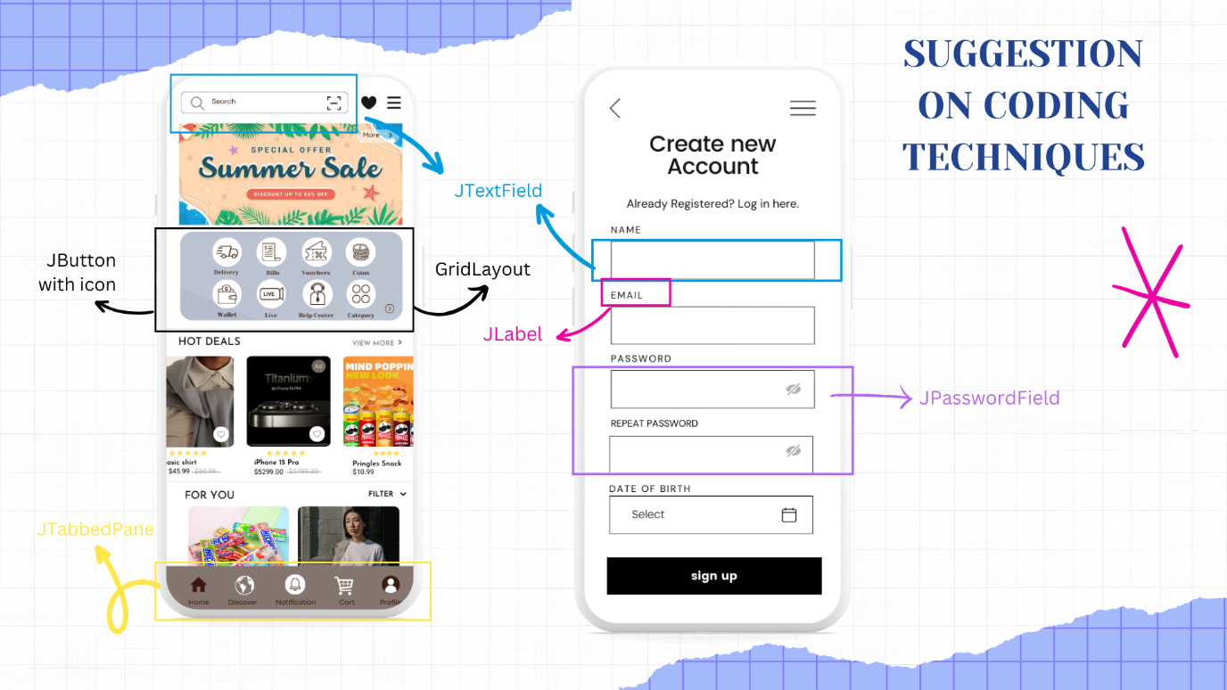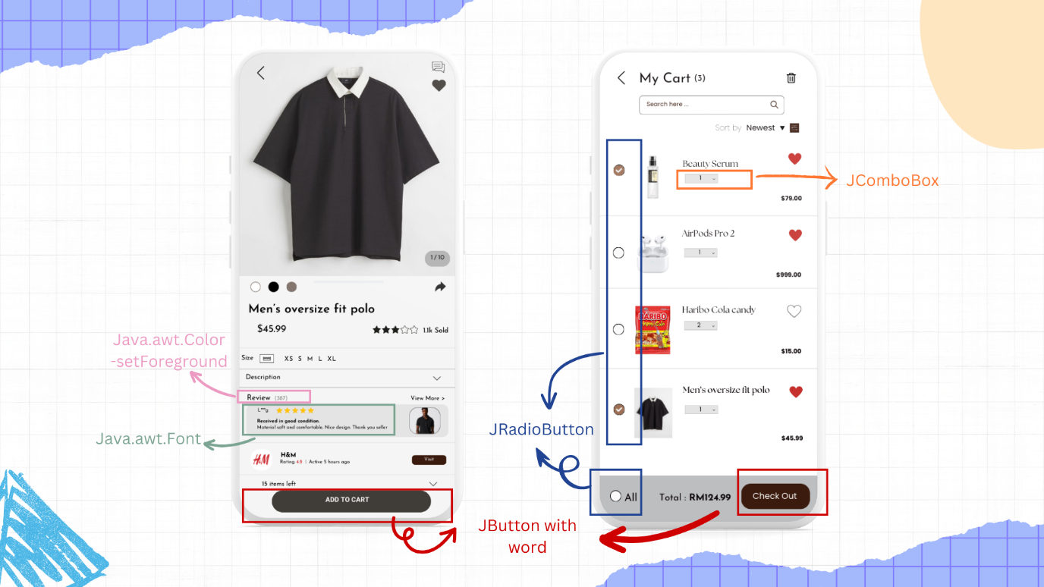

Appendix
Name: Hoh Xin Hui  Student ID: 23080609 | - Suggestion on Coding Techniques  - Mock-up Design  - Video Presentation (Marketing and Promotion and Suggestion on coding technique)
Name: Lim Feng Wei  Student ID: 23062334 | - Problem Statement  - Review of Existing Application: Shopee  - Review of Existing Application: Lazada  - Review of Existing Application: SHIEN  - Proposal of application  - Video Presentation (Problem Statement and Existing application Reviews)
Name: Sian Yi Xuan  Student ID: 23099609 | - Stakeholders  - Market reach & Target Audience  - Monetizing strategy  - Video Presentation (Stakeholders, Target Audience and Monetizing strategy)
Name: Teoh En Yi  Student ID: 23051105 | - Mock-up Design  - Logical Flow  - Video Presentation (Application Proposal and Mock-up design)

References
Fernando, J. (2024a, February 20). What are stakeholders: definition, types, and examples.
Investopedia. https://www.investopedia.com/terms/s/stakeholder.asp
Fernando, J. (2024b, March 6). What is a payment gateway? how it works and example. Investopedia. https://www.investopedia.com/terms/p/payment-gateway.asp

Jain, S. (2020, April 26). How Shein’s UX Helps in reducing the Number of Returns. Medium. https://medium.com/@sheryansh011095/how-sheins-ux-helps-in-reducing-the-number-of-returns-6e0b7b9d62a2
‌
Jasmine Heather Tay. (2019, March 12). A UX case study on Shopee (and my redesign of it). Medium; Prototypr. https://blog.prototypr.io/a-ux-case-study-on-shopee-and-my-redesign-of-it-cb0cabd0d8d0

LaFleur, G. (2022, December 5). 10 e-commerce marketing strategies for your business. Customer Experience. https://www.techtarget.com/searchcustomerexperience/tip/E-commerce-marketing-strategies-for-your-business

Loh, L. W. (2021, February 9). Designing a Faster Shopping Experience for the Lazada App. Medium. https://liweiloh.medium.com/designing-a-faster-shopping-experience-for-the-lazada-app-10d0d7baed6

Planning your digital marketing strategy: Traffic & Quality. (n.d.). Click Pilot. https://www.clickpilot.co.uk/blog/planning-your-digital-marketing-strategy-why-its-crucial-to-focus-on-traffic-and-quality/#:~:text=Traffic%20is%20the%20number%20of,the%20number%20of%20these%20visitors.

‌Seet, F. (2023, September 18). UI/UX Audit: Shopee vs Lazada. Snappymob Blog. https://blog.snappymob.com/ui-ux-audit-shopee-vs-lazada#Phase_7_Individual_Product_Page

‌Takahashi, L. (2022, October 4). UX/UI Case study: Shein Redesign. Medium. https://bootcamp.uxdesign.cc/ux-ui-case-study-shein-redesign-134e37cd3935
‌
Tambe, R., & Bhat, S., Jayaram. (n.d.). 13 Problems Faced by Customers While Shopping Online and How To Solve It» Smart Sight Innovations. https://www.smartsight.in/technology/problems-faced-customers-shopping-online-how-solve/

‌Teck, S. P. (2021, March 12). Case study: Creating a better Lazada experience. Medium. https://bootcamp.uxdesign.cc/creating-a-better-lazada-experience-70251b1b58ab

Top retail websites in Malaysia - Top rankings February 2024. (2024, March 12). Semrush. https://www.semrush.com/website/top/malaysia/e-commerce-and-retail/

View of IMPACT OF COVID-19 ON MALAYSIAN E-COMMERCE | International Journal on Recent Trends in Business and Tourism (IJRTBT). (n.d.). https://ejournal.lucp.net/index.php/ijrtbt/article/view/1464/1624
What is Content Marketing? Content Marketing Definition | Mailchimp. (n.d.). Mailchimp. https://mailchimp.com/marketing-glossary/content-marketing/#:~:text=Content%20marketing%20is%20a%20marketing,to%20buy%20what%20you%20sell.

Video link
https://drive.google.com/file/d/1jh1Xe4WQP0wJvdOJRtxNez3QX66S0m_d/view?usp=sharing

